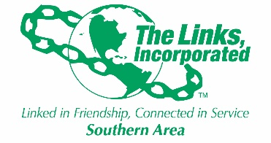

SERVICES TO YOUTH FACET MEETING
MONDAY, NOVEMBER 17, 2025, AT 8:00 PM

AGENDA

- Call to Order Link Lisa Sido
- Prayer Link Lisa Sido
- Minutes of last meeting Link Christina Sadler
- STY Revised Budget Link Lisa Sido
- Update on Mobile Book Library at Woodhill Elem. Link Maya Feemster-Jones
- Report on LIFE Umbrella Program Link Leah Moody
- Update on Gaston Literacy Reading Soulmates Link Robin and Link Jack
- Links Love HBCUs program update Link Leah and Link Jack
- Update on the National STEMS Program Link Lisa Sido
- Update on Dressing Her from the inside out program Link Robin Smith
- Matters Arising All Members
- Report on Family Literacy Initiative Link Christina and Link Brett
- Adjournment Lisa Sido

